IBM SkillsBuild
Student Portal

User Manual
Sprint 1 — Checkpoint 1
Version 1.0 · February 2026

Table of Contents

1. Introduction 3
2. Getting Started 3
2.1 System Requirements 3
2.2 Accessing the Portal 3
3. Creating an Account 4
4. Logging In 5
5. Homepage & Navigation 6
6. Student Dashboard 7
6.1 Searching for Courses 7
6.2 Starting a Course 8
6.3 Marking a Course as Complete 8
7. Browsing All Courses 9
8. My Profile 10
8.1 Updating Profile Details 10
8.2 Viewing Achievements 11
8.3 Unlocking Achievements 11
9. Leaderboard 12
10. Logging Out 12
11. Troubleshooting 13

1. Introduction
The IBM SkillsBuild Student Portal is a gamified web application that helps university students discover, track, and complete IBM SkillsBuild online courses. As students complete courses they earn Experience Points (XP), level up their profile, and unlock achievements. A leaderboard allows students to compare their progress with peers, creating a motivating and competitive learning environment.

This user manual covers every feature delivered in Sprint 1 of the project. It is intended for any registered student and provides clear, step-by-step guidance for each feature, accompanied by screenshots of the actual application.

2. Getting Started

2.1 System Requirements
No software installation is required. To use the portal you will need:

Requirements
- A modern web browser: Google Chrome, Mozilla Firefox, or Microsoft Edge (latest version recommended).
- A stable internet connection.
- JavaScript must be enabled in your browser (enabled by default in all major browsers).

2.2 Accessing the Portal
Open your web browser and enter the URL provided by your system administrator or module tutor (e.g. http://localhost:8080 in a local development environment). The Login page will load automatically.

ℹ️ Note
If the page does not load, confirm that the application server is running and that your internet connection is active. Try refreshing the page (F5 or Ctrl+R).

3. Creating an Account
Before using the portal you must register for an account. Registration is free and takes less than a minute to complete.

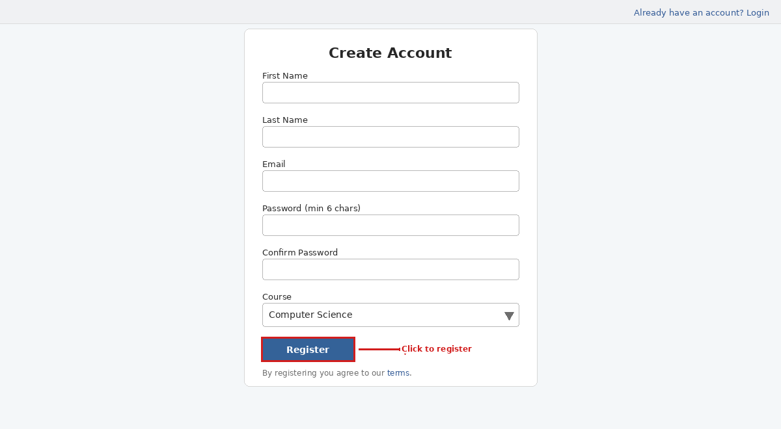
Figure 1 – Create Account page

# | Action
1 | Navigate to the portal URL in your web browser. The Login page will appear.
2 | Click the link in the top-right corner labelled "Need an account? Register". You will be taken to the Create Account page (shown above).
3 | Complete the registration form using the fields described in steps 4–9.
4 | First Name – Enter your given (first) name.
5 | Last Name – Enter your family (last) name.
6 | Email – Enter a valid email address. This is what you will use to log in.
7 | Password – Choose a password containing at least 6 characters.
8 | Confirm Password – Re-type your password exactly as entered above.
9 | Course – Select your degree programme from the drop-down: Computer Science, Software Engineering, Artificial Intelligence, or Data Science.
10 | Click the blue Register button to submit the form.
11 | If successful you will be redirected to the Login page. If an error message appears (e.g. passwords do not match), correct the highlighted field and try again.

✅ Tip
Your email address and password are case-sensitive. There is no automated password-reset in this version, so keep your credentials in a safe place.

4. Logging In
Once you have registered, you can log in at any time using your email address and password.

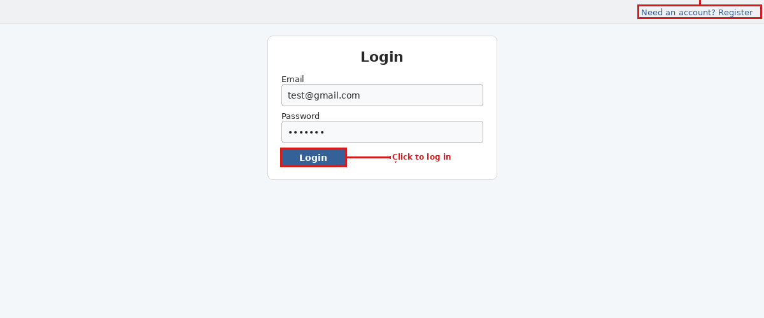
Figure 2 – Login page

# | Action
1 | Open the portal URL in your browser. The Login page will appear (shown above).
2 | Enter your registered Email address in the Email field.
3 | Enter your Password in the Password field.
4 | Click the blue Login button.
5 | If your credentials are correct you will be taken to the Homepage.
6 | If the error message "Invalid email or password" is shown, check for typing errors and try again.

⚠️ Important
If you cannot log in and believe your credentials are correct, contact your system administrator. There is no self-service password-reset feature in this version.

5. Homepage & Navigation
After a successful login you are taken to the Homepage. This is the central navigation hub for all sections of the portal.

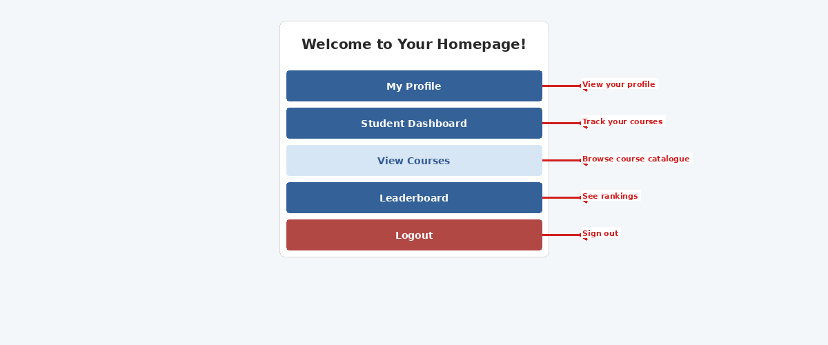
Figure 3 – Homepage showing the five navigation buttons

Feature / Item | Description
My Profile | View your current level, update your personal details, and manage your achievements.
Student Dashboard | Track your IBM SkillsBuild course progress: start courses, mark them complete, and search the catalogue.
View Courses | Browse the full IBM SkillsBuild course catalogue and view the status of each course.
Leaderboard | View a ranked table of all students ordered by XP score.
Logout | Securely end your current session and return to the Login page.

Click any button to navigate to that section. Use the browser's Back button or return to the Homepage to switch between sections at any time.

6. Student Dashboard
The Student Dashboard is your main workspace for managing course activity. It is organised into three sections: Started Courses, Available Courses, and Completed Courses. A search bar at the top lets you quickly filter courses by keyword.

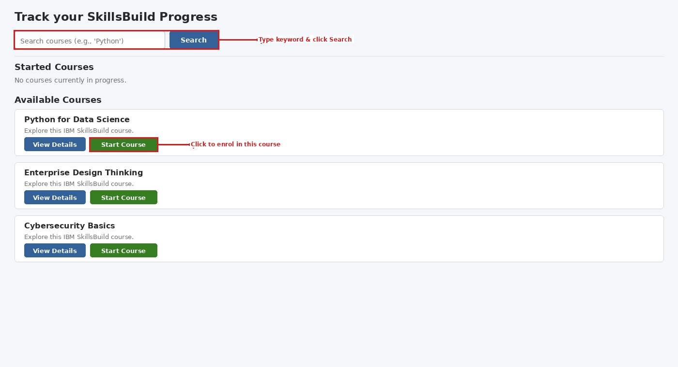
Figure 4 – Student Dashboard showing Available Courses and the search bar

6.1 Searching for Courses
Use the search bar to filter courses by keyword, making it easier to find a specific course in the catalogue.

# | Action
1 | On the Student Dashboard, locate the search bar at the top of the page (labelled "Search courses (e.g., 'Python')").
2 | Type a keyword (e.g. "Python", "Cloud", or "AI") into the search box.
3 | Click the blue Search button. The page reloads showing only courses whose titles match your keyword.
4 | To remove the filter and see all courses again, click the Clear Search link that appears next to the Search button.

6.2 Starting a Course
When you find a course in the Available Courses section that you want to take, you can enrol directly from the Dashboard.

# | Action
1 | Scroll down to the Available Courses section on the Dashboard.
2 | Find the course you wish to begin.
3 | Click the blue View Details button to open the IBM SkillsBuild course page in a new tab and preview the content.
4 | When ready to begin, click the green Start Course button. The course will move to your Started Courses section.

6.3 Marking a Course as Complete
After finishing all content for a course on the IBM SkillsBuild website, return to the portal and mark it complete to earn XP.

# | Action
1 | Scroll to the Started Courses section on the Dashboard.
2 | Find the course you have finished.
3 | Optionally, click the blue Resume Course button to revisit the material.
4 | Click the green Mark as Complete button. The course moves to the Completed Courses section and XP is added to your account.

✅ Tip
After marking a course complete, visit your Profile page and click Unlock Achievement to check for any newly awarded achievements.

7. Browsing All Courses
The View Courses page gives an overview of the entire IBM SkillsBuild catalogue and shows the current status of every course. Course data is loaded dynamically from the server each time the page opens.

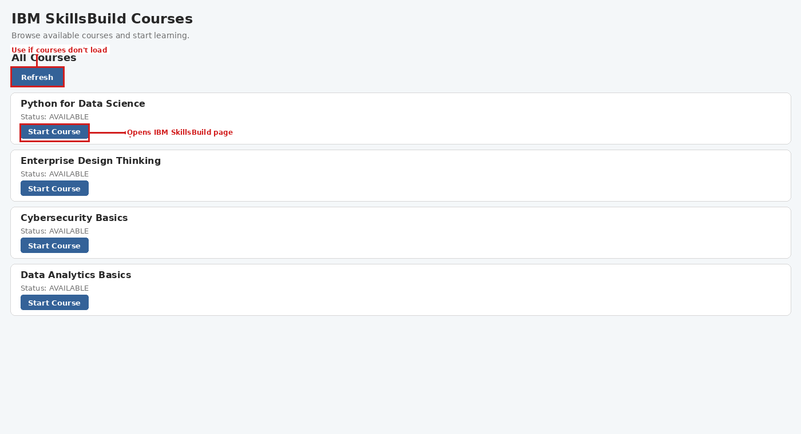
Figure 5 – View Courses page showing available IBM SkillsBuild courses

# | Action
1 | From the Homepage, click the View Courses button.
2 | The page loads and automatically displays all courses. If courses do not appear, click the Refresh button at the top of the page.
3 | Each course card shows the course title, its current status (e.g. AVAILABLE), and its unique Course ID.
4 | Courses with status AVAILABLE have an active Start Course button. Click it to open the IBM SkillsBuild website and begin that course.
5 | Courses with status STARTED or COMPLETED show a greyed-out (disabled) Start Course button – no further action is needed here for those courses.
6 | To manage progress (e.g. mark a course complete), return to the Student Dashboard.

Feature / Item | Description
AVAILABLE | You have not yet started this course. An active Start Course button is shown.
STARTED | You have enrolled in this course. The button is disabled; continue on the IBM SkillsBuild website.
COMPLETED | You have marked this course complete in the portal. The button is disabled.

8. My Profile
The Profile page shows your current level, lets you update your personal information, view your earned achievements, and unlock new ones.

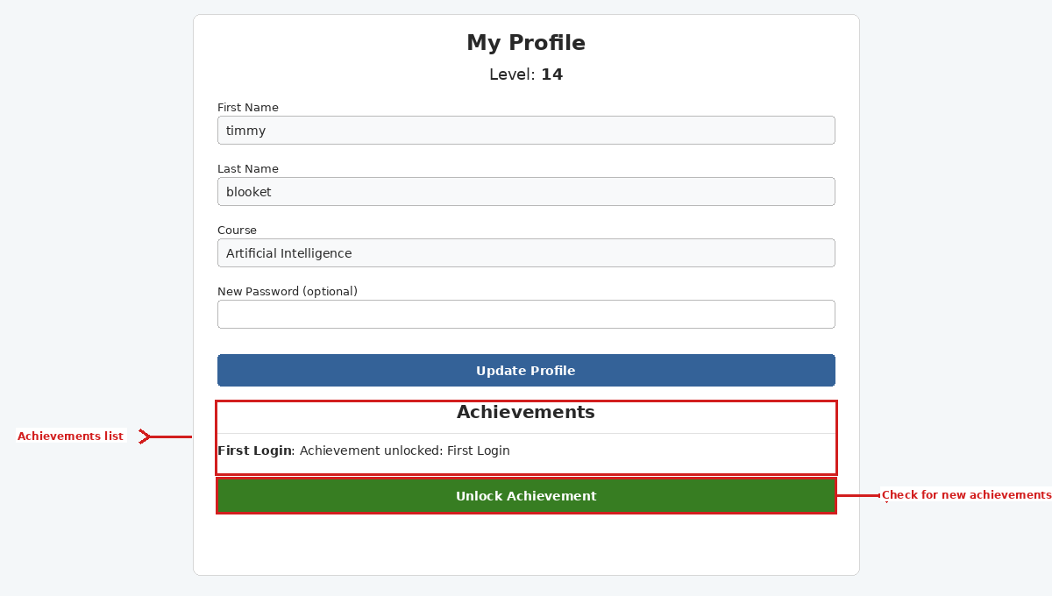
Figure 6 – My Profile page showing level, editable fields, and the Achievements section

8.1 Updating Profile Details
You can update your first name, last name, course, and password at any time from the Profile page.

# | Action
1 | From the Homepage, click the My Profile button.
2 | Your current Level is displayed at the top of the page (e.g. Level: 14 as shown above).
3 | Edit any of the following fields as needed:
4 | First Name – Update your given name.
5 | Last Name – Update your family name.
6 | Course – Update your degree programme.
7 | New Password (optional) – Enter a new password only if you want to change it. Leave this field blank to keep your existing password.
8 | Click the blue Update Profile button to save your changes.
9 | A confirmation message will indicate whether the update was successful.

⚠️ Important
If you leave the New Password field blank, your existing password will NOT be changed. Only fill in this field if you specifically want to set a new password.

8.2 Viewing Achievements
Achievements are rewards awarded automatically when you reach certain milestones, such as completing your first course or logging in for the first time.

# | Action
1 | Scroll below the Update Profile form on the Profile page.
2 | The Achievements section lists every achievement you have earned, showing the achievement title and a description (e.g. "First Login: Achievement unlocked: First Login").
3 | If no achievements are listed yet, continue using the portal – complete courses and return to check for new ones.

8.3 Unlocking Achievements
After completing courses or other actions, use the Unlock Achievement button to prompt the system to award any newly earned achievements.

# | Action
1 | On the Profile page, scroll to the bottom of the Achievements section.
2 | Click the green Unlock Achievement button.
3 | The system checks your recent activity and awards any achievements you have newly qualified for.
4 | Newly granted achievements will appear immediately in the Achievements list above.

9. Leaderboard
The Leaderboard shows all registered students ranked by their XP (Experience Points) score. XP is earned by marking IBM SkillsBuild courses as complete in the Student Dashboard. The higher your XP, the higher your position.

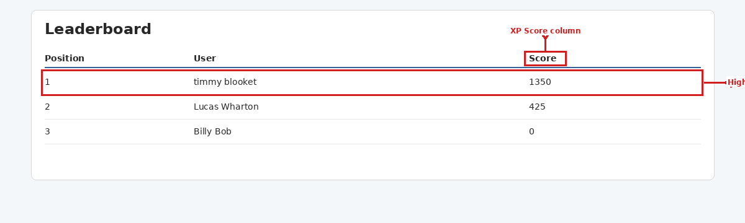
Figure 7 – Leaderboard showing students ranked by XP score

# | Action
1 | From the Homepage, click the Leaderboard button.
2 | The Leaderboard page loads automatically, displaying a ranked table of all students.
3 | The table shows each student's Position, Full Name, and XP Score.
4 | Find your own row to see where you rank among your peers.
5 | To improve your position, return to the Student Dashboard and complete additional IBM SkillsBuild courses to earn more XP.

ℹ️ Note
The leaderboard is refreshed automatically each time the page loads. XP changes from completing a course will be reflected the next time you open the Leaderboard page.

10. Logging Out
Always log out when you have finished using the portal, particularly on shared or public computers.

# | Action
1 | From the Homepage, click the red Logout button at the bottom of the navigation menu.
2 | Your session is ended securely and you are returned to the Login page.
3 | To use the portal again, log in with your email and password as described in Section 4.

⚠️ Security Reminder
Do not leave the portal open and unattended. Always click Logout when you have finished your session to protect your account.

11. Troubleshooting
If you experience a problem, refer to the table below for common issues and their solutions.

Feature / Item | Description
Page does not load | Check that the server is running and your internet connection is active. Refresh the page (F5 or Ctrl+R).
"Invalid email or password" | Check for typing errors – email and password are both case-sensitive. Contact your administrator if the issue persists.
Registration error message | Ensure all fields are filled, both password fields match, and the password is at least 6 characters. Use an email address not already registered.
Courses not displaying | Click the Refresh button on the View Courses page. Check your internet connection and try again.
XP not updated after completion | Ensure you clicked Mark as Complete on the Student Dashboard. Finishing a course on the IBM SkillsBuild website alone does not update the portal.
Achievement not awarded | Click the green Unlock Achievement button on the Profile page after completing a qualifying action.
Cannot update profile | Ensure all required fields contain valid data. Reload the page and try again.

IBM SkillsBuild Student Portal · User Manual · Sprint 1 · v1.0 · February 2026

